Company creation:

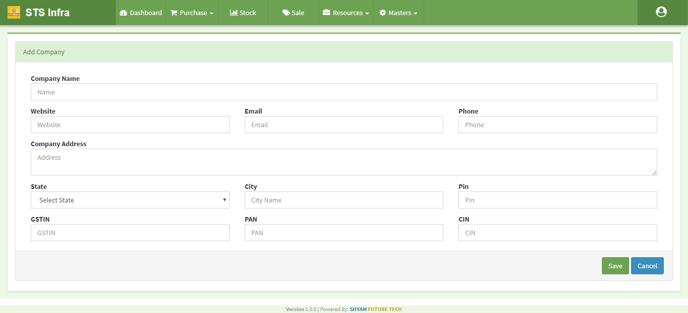

From here we can create new company and after that we can assign branches and banks to this particular company.

**Indent Management:**

This functionality is available on Purchase menu at top bar Dropdown. Here You will get all the list of indents as well as you can create new indent from this listing page on clicking new indent Button on top right corner.

On add new indent page there are some dropdown lists which you need to fill before proceeding namely company, location ,projects etc. After that add items for the indent. You can add more items on this section one by one. There are also special note for indent ( optional ) and save the indent on saving indent you will redirected to list of indents page where you can find the indent which you have just created.

You can edit the indent as well as approve the indent though these options are permission based. On approving the indent this will be made available for purchase order.

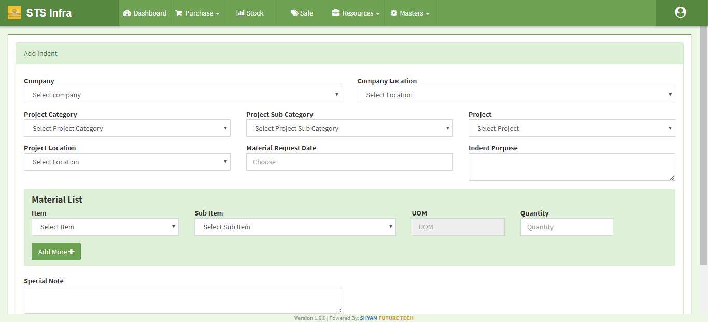

**Purchase Order:**

This functionality is available on Purchase menu at top bar Dropdown. Here You will get all the list of Purchase order as well as you can create new purchase order from this listing page on clicking new Purchase order Button on top right corner.

On add new purchase order page there are some dropdown lists which you need to select

Before proceeding namely company, location, projects etc. But here data depends on indent no.

you show here a select indent dropdown and all the approve indents are listing in this dropdown. Then show Indent detail, Material Requested List and other charges .Now other charge are not completed yet.(One to many relationship with indents )

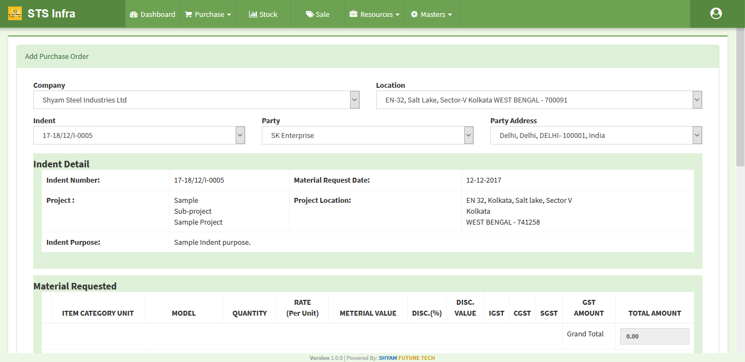

**Grn (Good Received Note) :**

This functionality is available on Purchase menu at top bar Dropdown . Here You will get all the list of GRN as well as you can create new GRN from this listing page on clicking new GRN Button on top right corner.

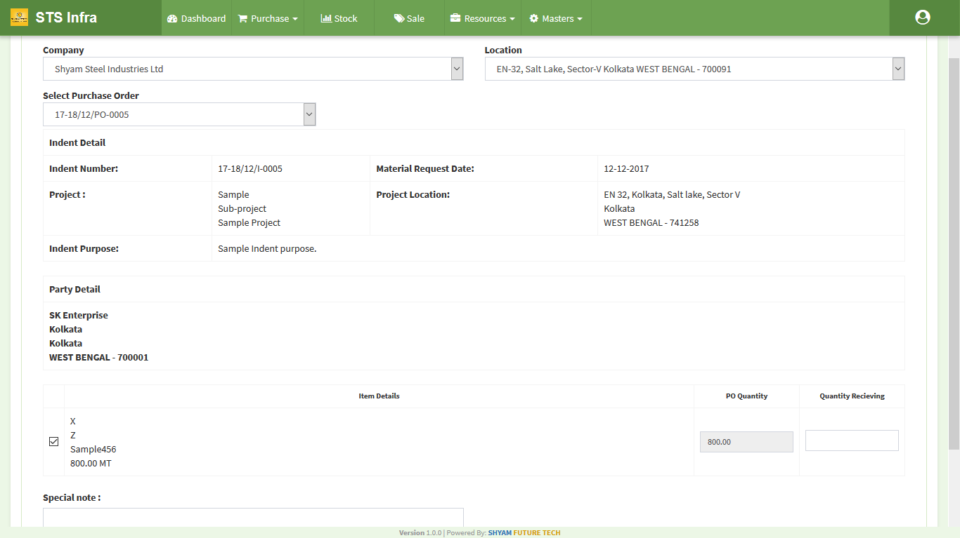

On Add new GRN page there are some dropdown list which you need to select Before proceeding namely company,location,projects etc. But here data depends on purchase order (Po no).

you show here a select purchase order (po no) dropdown and all the apporve indents are listing in this dropdown. Then show Indent detail , Material Requested List and other charges .Now other charge are not completed yet.(One to many relationship with po order )